Repository Week2

1-I want to know how many employees with each title were born after 1965-01-01.

**select** t.title **as** "Title", **count**(e.emp_no) **as** "Employee Sum"

**from** titles t

**inner** **join** employees e

**on** t.emp_no = e.emp_no

**where** e.birth_date > '1965-01-01'

**group** **by** t.title

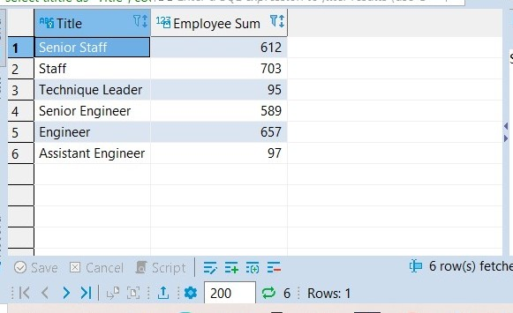

2- I want to know the average salary per title.

**select** t.title **as** "Title", **avg**(s.salary) **as** "Average Salary"

**from** salaries s **inner** **join** titles t

**on** s.emp_no = t.emp_no

**group** **by** t.title

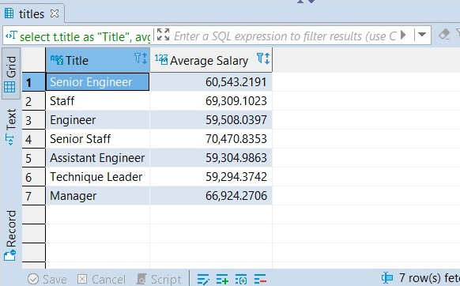

3. How much money was spent on salary for the marketing department between the years 1990 and 1992?

**select** d.dept_name **as** "Department", **sum**(s.salary) **as** "Salary"

**from** employees e

**inner** **join** salaries s **using** (emp_no)

**inner** **join** dept_emp de **using** (emp_no)

**inner** **join** departments d **using**(dept_no)

**where** d.dept_name = "Marketing" **and** de.to_date <= '1991-12-31' **and** de.from_date >= '1990-01-01'

